Memo on Level 1B Annotated Direct Event Spinphase
May 14, 2026
N. A. Schwadron
We are observing anomalies in the spinphase distributions for certain days in the Level 1B annotated Direct Event (DE) data products. Here, we compare representative cases of spinphase distributions derived from Level 1A and Level 1B processing.
In the Level 1A data products, the spinphase is determined directly from onboard timing information, specifically the event timestamp relative to the spacecraft spin pulse. In contrast, the Level 1B annotated DE products derive spinphase using SPICE-based spacecraft attitude reconstruction.
The comparisons below indicate that the Level 1A products show the expected narrow spinphase distributions, whereas some Level 1B products exhibit broadened distributions and extended background structure. These discrepancies suggest issues associated with the current attitude-based spinphase reconstruction used in the Level 1B annotation process.
We show representative examples for repoint 175 and repoint 199.
The IMAP-Lo team plans to rework the pipeline so that future processing relies directly on the Level 1A timing information for spinphase determination. This approach avoids dependence on the current attitude reconstruction pathway and is expected to eliminate the observed artifacts.

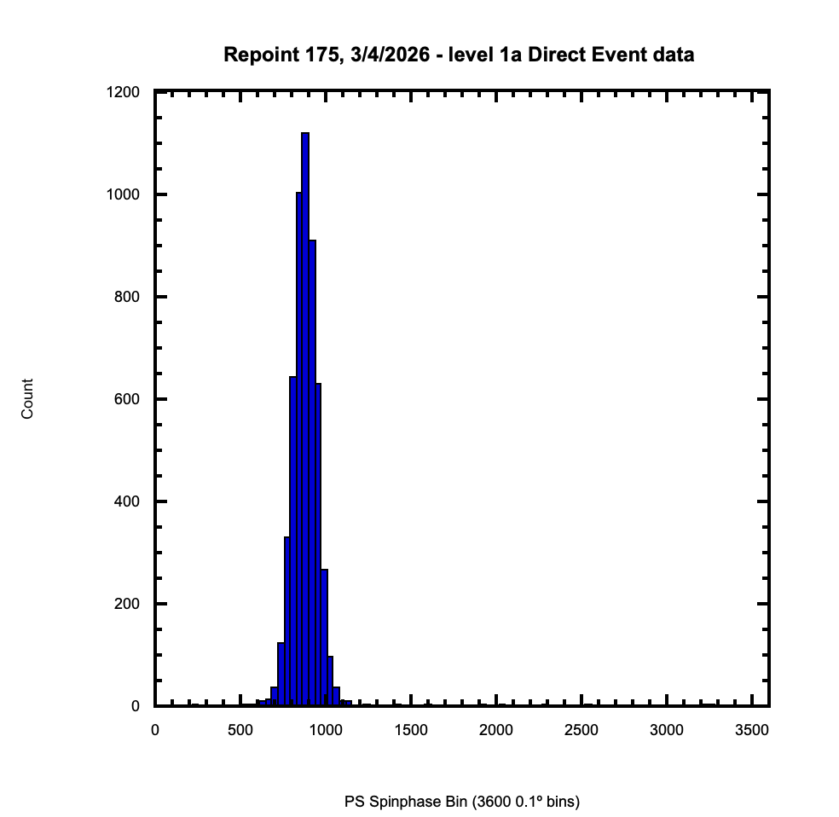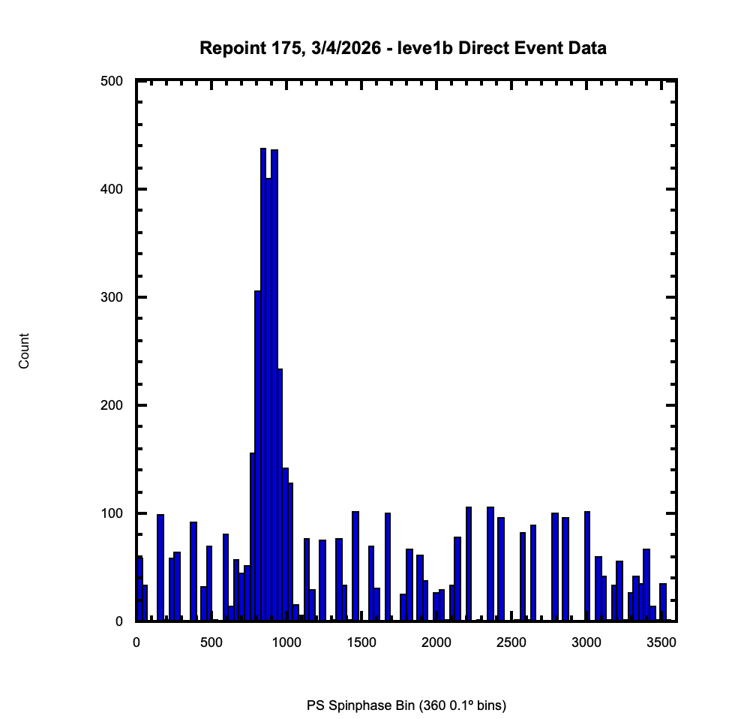
Figure 1: Comparison of Level 1A and Level 1B Direct Event spinphase distributions of Oxygen for repoint 175. The Level 1A distribution exhibits the expected narrow peak structure, while the Level 1B annotated data show additional broad background and anomalous structure.

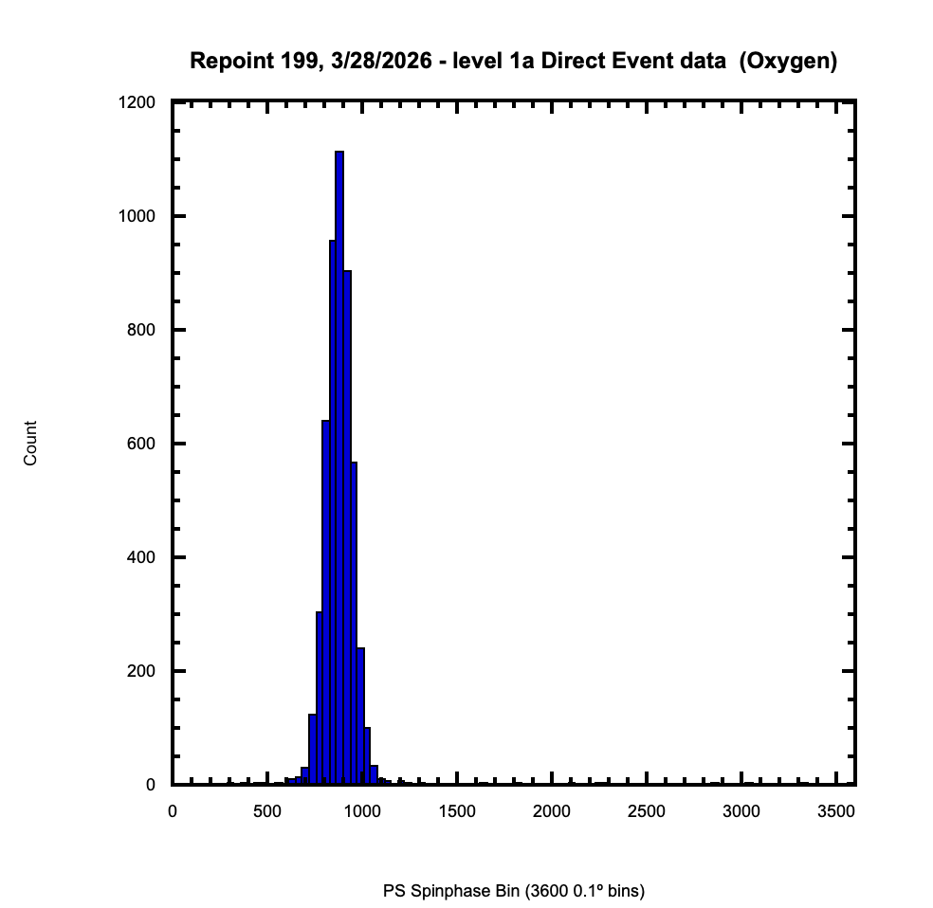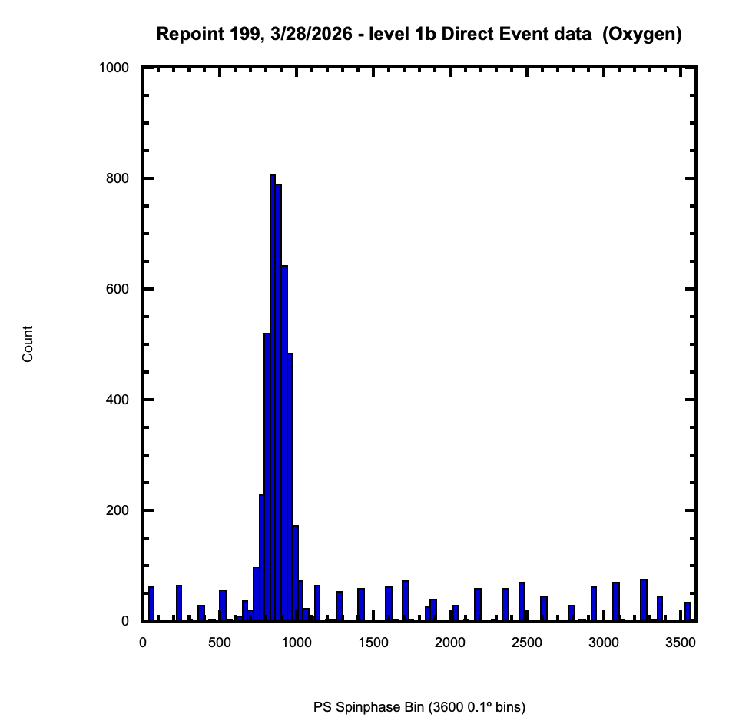
Figure 2: Comparison of Level 1A and Level 1B Direct Event spinphase distributions of Oxygen for repoint 199. Similar anomalies are observed in the Level 1B annotated products, consistent with issues in the current spinphase reconstruction methodology.

